BSC (Hons) International Hospitality Management
Databases
THE5001
MICHAIL SIDERIS
BoltonID: 2526787
Marking tutor: Konstantinos Tsakonas
Date of submission: 5/4/2026

Contents
Abstract 3
Introduction 3
Literature Review 3
Methodology 3
Results/Findings 3
Discussion 3
Conclusion & Recommendations 3
References 3
Appendices 3

Abstract

Introduction
In this report I will examine how a bank would design a data base to manage credit cards and transactions. In todays world it is really important for a bank to have a clean and organized way to store information about their customers, their accounts and their transactions.
The system works by tracking how people use their credit cards. For example one customer can have multiple accounts and each one of their cards is linked to one of these accounts. The database will also track a clients activity. It will record every time a card is being used at a store and every time a client makes a payment. It will also track the locations of customers and stores, which helps the bank in understanding the clients spending habits.
The objective is to create a high quality database by visualizing the database using a entity relationship diagram(ERD).By creating a relationship model in order to show how different tables connect. And finally clearing the database by using normalization to make sure there is no wasted space and that the database runs smoothly and as fast as possible.

Literature Review
So basically I made this database based on some basic ideas about how to organize information properly. Things like drawing diagrams to show how everything is connected and making sure the data is stored in a clean and logical way. Key principles such as entity relationship modeling, normalization, and relational schema design were applied in the assignment. Many experts, like Elmasri and Navathe, say that Entity-Relationship Diagrams (ERDs) are helpful because they let you see how different parts of a system connects before you actually build the database. This makes everything easier to understand and helps prevent mistakes. Normalization is very important for cutting down repeated data and keeping information accurate. It means arranging data into different connected tables to avoid errors when updating and to keep everything consistent. In this project, the three main normal forms 1NF, 2NF, and 3NF were used. Lecture materials were also used to support understanding of ERD design, weak entities, and relational mapping.

Methodology
To build the database firstly I looked at the requirements to choose the main entities like Customers, Accounts, Credit Cards, Transactions, Stores, Payments and Areas. I then decided which attributes to give to each one and give them Primary Keys.
Next I figured how these categories connect for example a customer can have multiple Accounts. An Account is linked to a credit card. Transactions occur at a specific store and a specific store is located to a specific area. Both costumers and stores are grouped by Area. I then created an entity relationship diagram(ERD) to create a visual map of the system. Then I turned that map to a Relationship Model which is a set of organized tables that use Foreign Keys(FK) to link each other.
Lastly I took a messy list of data and cleaned it up using Normalization. I did it in three stages (1NF, 2NF, 3NF).This removed redundancy and repetitive information and made the database more organized, effective and efficient.

Results/Findings
The dabase’s final part was made by using different tables that include the basic parts of the system. The tables that are being used are interconnected and are Customer, Account, CreditCard, Transaction, Store, Area, and Payment. All of the tables have information stored inside them. The Customer table has personal information stored inside. Each customer is connected to an area which has details of area name, population and average income. The Account table manages financial accounts that are linked to the customers and stores information about the accounts like account number, account balance and creation date. Since one customer can have more than one account there is a one to many relationship between Customer and Account. The CreditCard table connects cards to customers and accounts in addition to tracking transactions. It also stores information about each card like for example card number, issue date, expiry date, credit limit, balance and interest rate. Each credit card is linked to one account. The Transaction table keeps track of purchases made by credit cards as well as the location of the transactions. It stores Transaction ID, amount, date, time and the location of the stores. The Store table contains details about stores, like store ID, name, and type of service. Stores are also linked to areas. The Payment table represents payments made by customers and uses a composite primary key like for example CustomerID, PaymentSerial reflecting its nature as a weak entity. In the end, by applying normalization up to Third Normal Form (3NF), the database avoids repeating data and is more organized and efficient.

Discussion
While working on this database, I ran into a few difficulties. The main one was understanding how everything connects, especially between customers, accounts, and credit cards. I had to think carefully to make sure the relationships actually made sense. Next issue was with payment Serial as its not unique to everyone but for only each customer so I combined it with costumer ID to make it work and form a composite key which made things a bit more complicating. Normalization was also a bit confusing sometimes because it wasn’t always clear which data should be separated into different tables. Mistakes in normalization could lead to redundant data or loss of important relationships. Having to distinguish between partial and transitive dependencies took some time to understand how attributes depend on primary keys. Additionally, balancing simplicity and correctness was important. While it is possible to create many small tables the design needed to remain practical and understandable. Despite these challenges careful analysis and reference to theoretical concepts helped to ensure a correct and efficient final design.

Conclusion & Recommendations
So in the end what I made is a system that keeps everything nicely organized like a well arranged notebook. It stores information about people and their money in a clear and tidy way so its organized and nothing gets mixed up.I used some methods to make sure the information isn’t repeated again and again, and that everything is correct. Even though there are many connections between things everything fits together properly. If I had more time I could add more details like extra information about customers or different types of purchases. I could also build it in a real program to test it and see it working .Another thing I would improve is security, to make sure that only the right people can see or use the information since it’s something so important like money. But overall I think it turned out well. It shows that I understand how to organize information properly and it’s a good start for building something bigger in the future.

References
- Codd, E.F. (1970). A Relational Model of Data for Large Shared Data Banks
- Elmasri, R. & Navathe, S. (2016). Fundamentals of Database Systems
- Connolly, T. & Begg, C. (2015). Database Systems: A Practical Approach
- Date, C.J. (2004). An Introduction to Database Systems
- Silberschatz, A. et al. (2019). Database System Concepts
- Coronel, C. & Morris, S. (2016). Database Systems: Design, Implementation
- Rob, P. & Coronel, C. (2007). Database Systems Design
- Oracle Documentation (SQL Basics)
- MySQL Documentation
- IBM DB2 Documentation

No AI was used making this assignment

Appendices

Appendix A – System Requirements
This what the system is required to do:

The system must store costumer data like personal and contact information
The system must support multiple accounts
The system must store account details like balance,creation date,branch
The system must give out credit cards connected to customer accounts
The system must keep track of the transactions made using the credit cards
The system must have information about the credit cards like limit,interest rate,balance
The system must keep store infortmation including name and service type
The system must store each transaction to a specific store and a specific credit card
The system must keep track of customer payments towards credit card balances
The system must inforce that each payment must have a unique serial number per customer
The system must assign customers to geographical areas
The system must assign stores to geographical areas

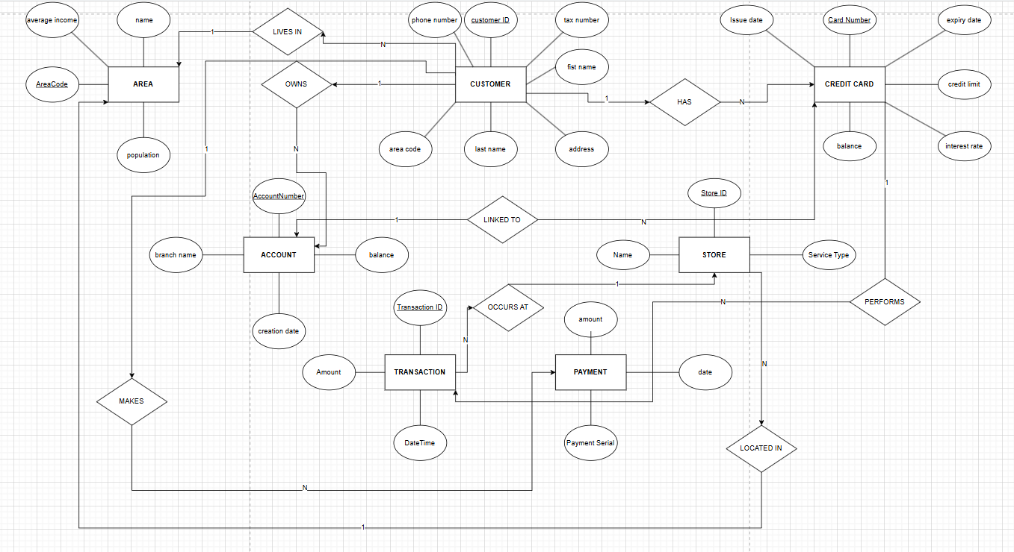
Appendix B – ERD

Appendix C – Relational Model

Customer:
CustomerID PK, FirstName, LastName, Address, TaxNumber, PhoneNumber ,AreaCode FK

Area:
AreaCode PK, Name, Population, AverageIncome

Account:
AccountNumber PK, Balance, CreationDate, BranchName, CustomerID FK

CreditCard:
CardNumber PK,IssueDate, ExpiryDate, CreditLimit, InterestRate, Balance, CustomerID FK AccountNumber FK

Store:
StoreID PK, Name, ServiceType, AreaCode FK

Transaction:
TransactionID PK, Amount, DateTime, CardNumber FK, StoreID FK

Payment: CustomerID FK, PaymentSerial, Date, Amount, CustomerID PK, PaymentSerial PK

Appendix D – Normalization Table
First Normal Form(1NF)
Improvements:
Each field contains a single value
Repeating groups are removed

Remaining issue:
Data redundancy

Customer ID | Name | Card Number | Store | Area | Transaction ID
1 | Michail | **** **** **** 1111 | Nike | Athens | 1001
1 | Michail | **** **** **** 1212 | Mpousoulas tou Kafe | Athens | 1002

Second Normal Form(2NF)

Improvements:
Data has multiple tables
Each attribute depends on its primary key

Remaining issue:
Transitive dependancy still exists

Customer
Customer ID | Name | Area
1 | Michail | Pireaus

Credit card

Card Number | Customer ID
**** ***** **** 1111 | 1
**** **** **** 1212 | 1

Transaction

Ttansaction ID | CardNumber | Store
1001 | **** ***** **** 1111 | Nike
1002 | **** **** **** 1212 | Mpousoulas tou Kafe

Third Normal Form(3NF)

Improvements:

Transitive dependancies are removed
Redudndancy is minimized
Data integrity is improved

Customer
Customer ID | Name | AreaCode
1 | Michail | 12345

Area

AreaCode | AreaName
12345 | Athens

Store

Store ID | Name | AreaCode
S1 | Nike | 12345

Credit Card

CardNumber | Customer ID
**** **** **** 1111 | 1

Transaction

Transaction ID | Card Number | StoreID
1001 | **** **** **** 1111 | S1

